Chapter 6 p.115

Graph showing the decrease in distinct IPs over a period. X-axis represents the period from April 23 to June 23 and y-axis represents Distinct IPs ranging from 700 to 1000 in intervals of 50. Line starts from 950 in April 23, decreases to 800 in May 23, further decreases to 750 in June 23. All the values are approximated.

**Active cracked Cobalt Strike C2s**

Decline in distinct IPs showing the impact of the disruption

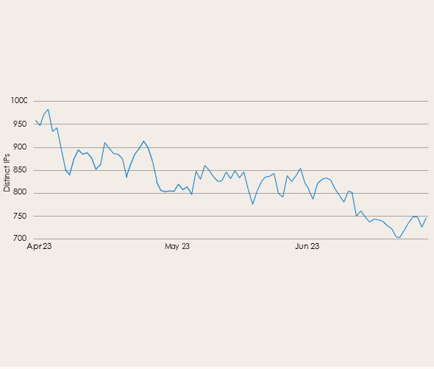

Source: Digital Crimes Unit investigations